**Test Case**

**N = 3, K = 11**

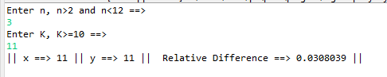

**N = 3, K = 30**

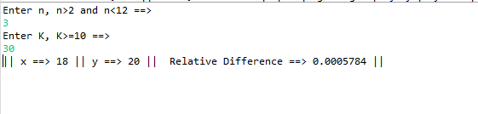

**N = 11, K = 15**

